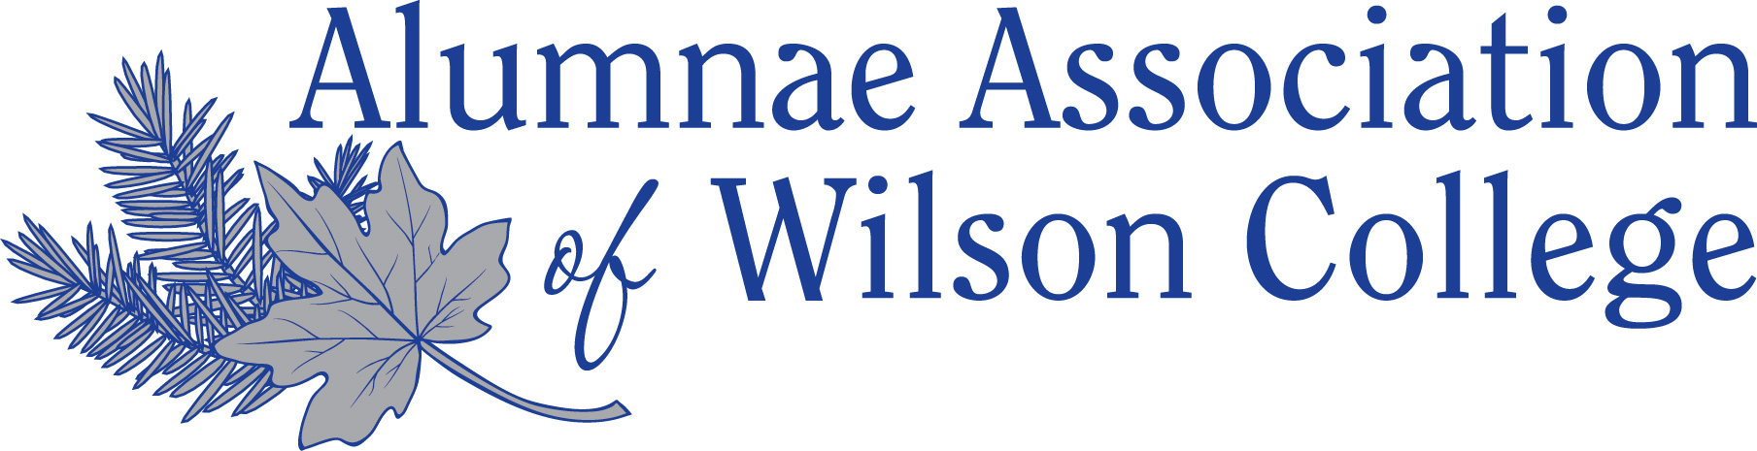

Alumnae Association of Wilson College – Code of Conduct Policy
(updated June 2018)

Purpose
The Alumnae Association of Wilson College (hereinafter referred to as the "Association")
believes that members of its Board of Directors, Nominating Committee and staff in the Office
of Alumnae/i Relations (hereinafter referred to as "staff') shall be committed to observing and
promoting the highest standards of ethical conduct in the performance of their responsibilities.
The principles and practices of ethical conduct shall provide guidance and direction for effective
governance.
Code of Conduct
Members of the Board of Directors, Nominating Committee and staff shall pledge to accept the
Code of Conduct as a minimum guideline for ethical conduct as they carry out certain duties and
responsibilities for the well-being of the Association and shall:
Accountability
- Faithfully abide by the Articles of Incorporation, Bylaws and policies of the Association.
- Exercise reasonable care, good faith and due diligence in governing and managing affairs
with respect to the principles of Duty of Care, Loyalty and Obedience.
- Fully disclose, at the earliest opportunity, information that may result in a perceived or actual
conflict of interest.
- Fully disclose, at the earliest opportunity, information of fact that would have significance in
board decision-making.
- Remain accountable for prudent fiscal management to Association members, the Board of
Directors, and nonprofit sector, and where applicable, to governmental bodies.
Professional Excellence - Integrity
- Maintain a professional level of courtesy, respect, and objectivity in all matters and activities.
- Strive to uphold those practices and assist other members of the Board of Directors,
Nominating Committee and staff in upholding the highest standards of conduct.
Personal Gain - Self-Dealing
- Exercise the powers invested by one's position for the good of all members of the
Association rather than for personal benefit.
Equal Opportunity - Diversity – Inclusivity

- Ensure the right of all members, volunteers and staff to access benefits and services without discrimination on the basis gender, sexual orientation, national origin, race, religion, age, political affiliation, disability or socio-economic aspects, in accordance with all applicable legal and regulatory requirements.

Alumnae Association of Wilson College
Code of Conduct
Confidential Information
- Respect the confidentiality of sensitive information relating to the affairs of the Association
acquired in the course of service and used for the purposes of governance and management,
except when authorized or legally required to disclose such information.
- Recognize that divulging information to outside parties could be damaging or sensitive to
other members or staff, harmful to the best interests of the organization, or even create legal
liability.
- Understand that the obligation to maintain confidentiality extends indefinitely beyond the
term of office.
Collaboration and Cooperation
- Respect the diversity of opinions as expressed or acted upon by the Board of Directors,
committees and Association membership, and formally register dissent as appropriate.
- Promote collaboration, cooperation, and partnership among Association members.
- Publicly support the majority decisions made by the Board of Directors.
Responsibilities
The Board of Directors is responsible for assuring communication and implementation of the
policy on Code of Conduct, and for enforcing compliance with its principles and practices.
The Nominating Committee is responsible for annually distributing the Code of Conduct to all
members of the Board of Directors, Nominating Committee and staff for review and signature. A
member who has concerns regarding compliance with the Code of Conduct shall raise those
concerns to the President of the Board and/or the Nominating Committee. In the unlikely event
that a waiver of this Code for a member would be in the best interest of the Association, it must
be approved by a unanimous vote of the Board of Directors.
The Director of Alumnae/i Relations is responsible for annually maintaining in the Office of
Alumnae/i Relations signed copies of the Code of Conduct for every member of the Board of
Directors, Nominating Committee and staff.
Acknowledgement of Receipt
I acknowledge that I have received and read a copy of the Code of Conduct and that I am responsible for compliance.

Date:_____________________________

Signature:_____________________________________

Printed Name:_______________________

